COUCHBASE CAPELLA Workshop

**Lab Handbook**

Lab 3: Connecting SDK Via Couchbase playground

# Lab Overview

The goal of this lab is to use the playground to connect to a Couchbase Capella cluster and perform some core functionality with the SDK.

# Lab Setup

## Step 1: Connecting to a Couchbase Capella cluster

### 1a: Create database credentials:

In the Connect tab of the Couchbase Capella Control Plan, click on **Database Access -> Manage Credentials**

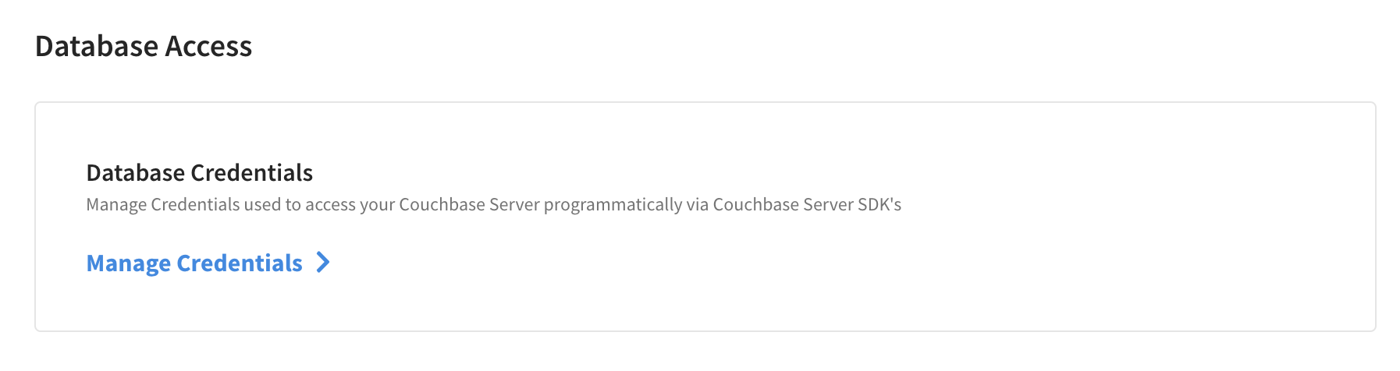

Create Database Credential for travel-sample bucket with read/write access

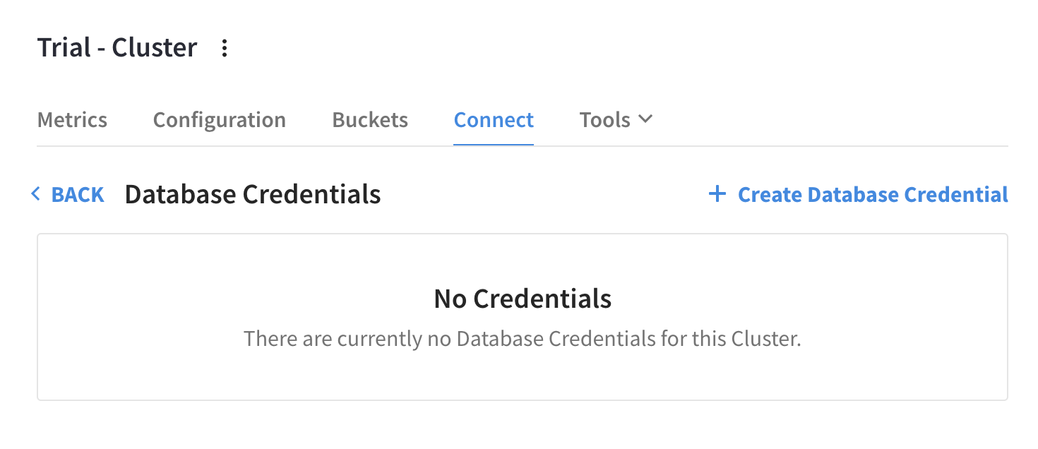

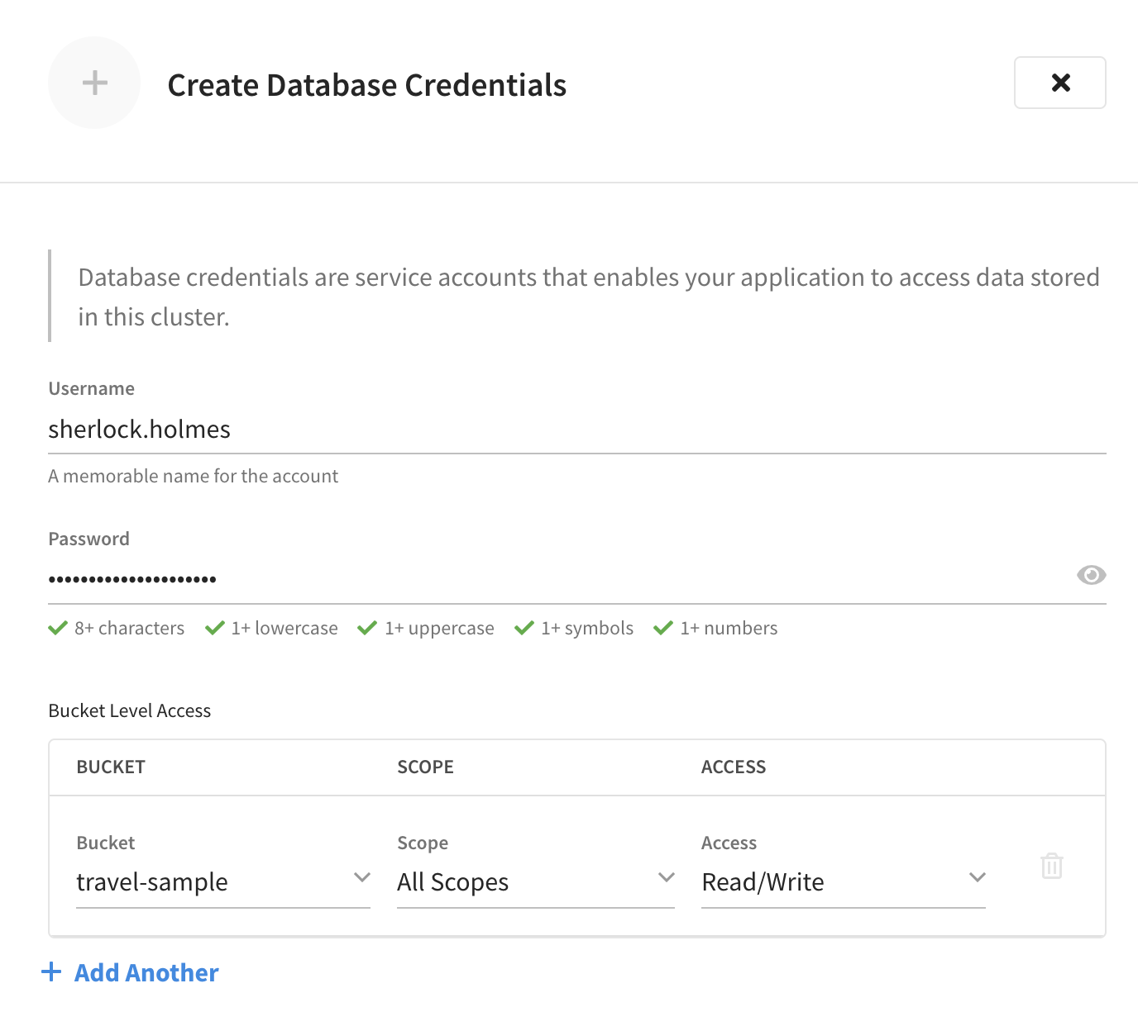

### 1b: Connection string

In the Connect tab of the Couchbase Capella Control Plane, the Wide Area Network field, copy the address. The SDK connection string should look like the following with the highlighted portion matching the participants specific address.

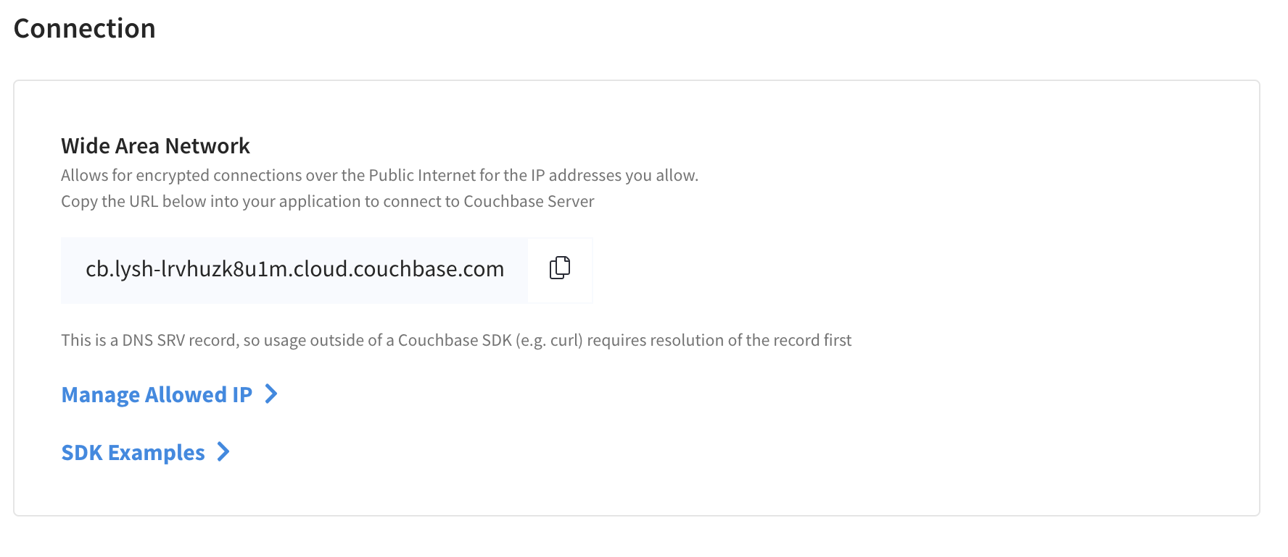

## Step 2: Create a session in Couchbase Playground

Go to <http://couchbase.live> and select Capella Session:

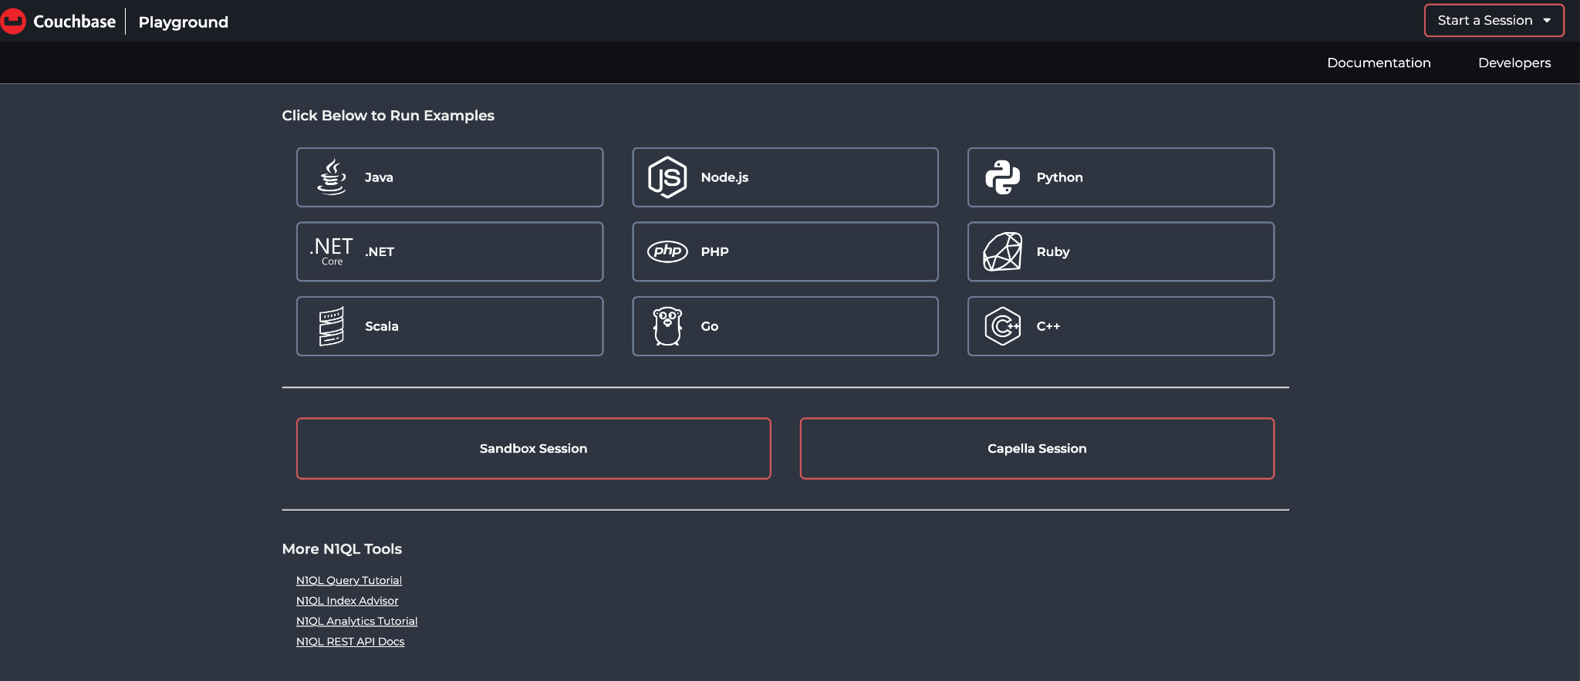

Fill the following fields with the necessary information as shown in the step 1. Please note that duration of the session is only 30minutes

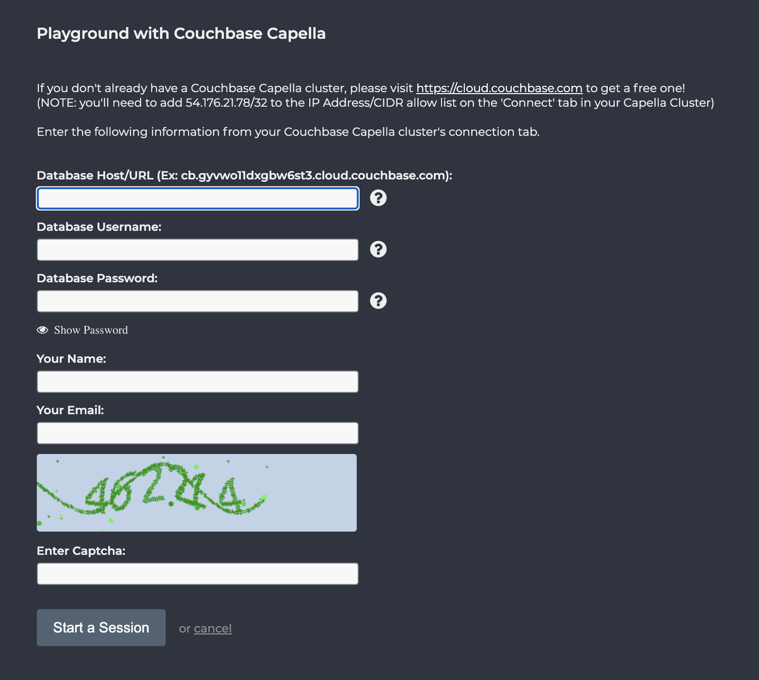

### Add IPv4 Address to Couchbase Capella

1. Go to the *Couchbase Capella Control Plane*
2. Select the cluster you want to connect with the SDK
3. Click on the *Connect* tab
4. Click the *Manage Allowed IPs* button
5. In the fly-out panel, paste your IP address from the previous step in the *IP Address or CIDR Block* field
6. Keep the *Save as Temporary* checkbox checked and set the number of hours
7. Click the *Add IP* button
8. Click the *Save* button

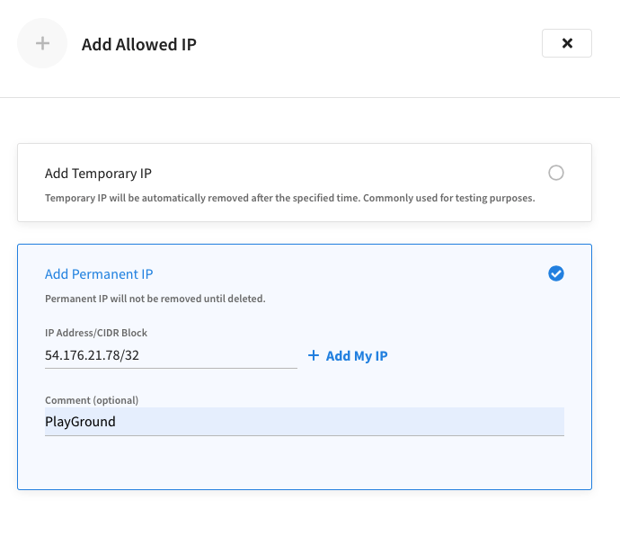

**Check the status of your session:**

The status should be “ ok” before to start the lab and run the examples



 